Obstacle avoiding robot
A project report submitted in partial fulfillment of the Academic requirements
for the award of the Degree of
BACHELOR OF ENGINEERING
IN
INFORMATION TECHNOLOGY
By
Ibrahim 2451-17-737-022
Vaseem 2451-17-737-023

Under the guidance of
Mr. D. B. V Sankar sir
Associate Professor, Dept. of I.T
MVSR Engineering College
Nadergul, Hyderabad.
(Month & Year)
/33


DEPARTMENT OF INFORMATION TECHNOLOGY
MVSR ENGINEERING COLLEGE
(Affiliated to Osmania University, Hyderabad. Recognized by AICTE)
Nadergul, Saroornagar Mandal, Hyderabad-501510
2018-2019
ACKNOWLEDGEMENT

We with extreme jubilance and deepest gratitude, would like to thank Mr. D. B. V Sankar sir,
Associate professor, Department of Information Technology, MVSR Engineering College, for his/her constant encouragement and facilities provided to us to complete our project in time.

With immense pleasure, we record our deep sense of gratitude to our beloved Head of the department Dr. Ch. Samson, Department of Information Technology, MVSR Engineering College, for permitting us to carry out this project.
We would like to extend our gratitude to Mr. P. Karthik, Assistant Professor and A Nirmala, Lab Assistant, Department of Information Technology, M V S R Engineering College, for his valuable suggestions and timely help during the course of the project.
We express, from the bottom of my heart, my deepest gratitude to my parents and family for the support, dedication, comprehension and love.
Finally, we express our heartfelt thanks to each and every one who directly and indirectly helped us in successful completion of this project work.

Ibrahim
2451-17-737-022

Vaseem

2451-17-737-023

ABSTRACT

The project is design to build an obstacle avoidance robotic vehicle using ultrasonic sensors for its movement. A micro-controller is used to achieve the desired operation. A robot is a machine that can perform task automatically or with guidance. Robotics is a combination of computational intelligence and physical machines (motors). Computational intelligence involves the programmed instructions. The project proposes robotic vehicle that has an intelligence built in it such that it directs itself whenever an obstacle comes in its path. This robotic vehicle is built, using a micro-controller. An ultrasonic sensor is used to detect any obstacle ahead of it and sends a command to the microcontroller. Depending on the input signal received, the micro-controller redirects the robot to move in an alternate direction by actuating the motors which are interfaced to it through a motor driver.
Contents

PAGE NO

- Introduction
1.1) Exiting system
1.2) Proposed
1.3) Applications
- Software and Hardware Requirements
- Model Description
- Design
- Implementation
- Testing (Component Testing/System/Circuit Testing)
- Results and Discussion
- Future Scope of work
- Conclusions
References
APPENDICES
CODE
Introduction
Obstacle avoidance is a primary requirement of any autonomous mobile robot. Obstacle avoidance Robotics design to allow robot to navigate in unknown environment by avoiding collisions.
Obstacle avoiding robot senses obstacles in the path, avoid it and resumes its running. There are some very famous methods for robot navigation like wall-following, edge detection, line following. One of the commercial systems uses wall following method on a floor cleaning robot for long hallways.
A more general and commonly employed method for obstacle avoidance is based on edge detection. A disadvantage with obstacle avoidance based on edge detecting is the need of the robot to stop in front of an obstacle in order to provide a more accurate measurement. All mobile robots feature some kind of collision avoidance, ranging from primitive algorithms that detect an obstacle and stop the robot in order to avoid a collision, using some sophisticated algorithms, that enable the robot to detour obstacles. The latter algorithms are more complex, since they involve detection of an obstacle as well as some kind of quantitative measurements concerning the obstacle's dimensions. Once these have been determined, the obstacle avoidance algorithm needs to steer the robot around the obstacle and resume motion toward the original target. In this paper the steering algorithm ensures that the robot does not have to stop in front of an obstacle during its navigation.
Hence the robots may overcome some of the problems during navigation, which are discussed above and it can navigate smoothly during its operation avoiding the collisions. We have presented a basic algorithm and design which can be further improved depending upon the required applications.

Existing systems:
In simple robot, steering algorithm is used for robotic actions in which driver or a human being is controlling the robot using remote. Here driver is present, who can see the obstacle and navigate robot accordingly.

Proposed system:
The project proposes an autonomous robotic vehicle, in which no remote is used for controlling the robotic actions. It intelligently detects obstacles present on its path through the sensors, avoid it and take decision on the basis of internal code that we set for it. The detail information is given in the following subtopics which will help you to understand the whole system and its design.

Applications:
Almost all navigation robot demands some sort of obstacle detection, hence obstacle avoidance strategy is of most importance. Obstacle Avoidance Robot has a vast field of application.
1.They can be used as services robots, for the purpose of household work and so many other indoor applications.
2.Obstacle seeing robot can be applied at toys where small children will play.
3.It can be used for army applications.
4.Can be used in dangerous environments, where human penetration could be fatal.
5.Used in mobile robot navigation system.
Software and Hardware Requirements:
Software:
PC running windows Xp or higher, Arduino IDE software.
Hardware:
- Arduino Uno
- Ultrasonic sensor
- Motor shield
- Geared motors x 2
- Robot chassis
- Power supply

Flow chart:
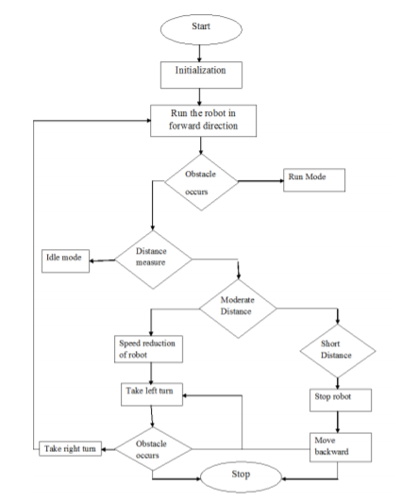
Fig.3: Obstacle Avoidance Flowchart

Basic design of robot:
This robot was built with an Arduino development board on which microcontroller is placed. Arduino board is connected with DC Motor through Motor driver board (pin10, pin11, pin12, pin13) which provide power to the actuators. Actuators are used to move robot in Forward, Backward, Left and Right directions. The brief description of inputs pins for movement of robot is given in below in table.

Movement | Pin 10 | Pin 11 | Pin 12 | Pin 13
Forward | 1 | 0 | 0 | 1
Backward | 0 | 1 | 1 | 0
Left | 1 | 0 | 1 | 0
Right | 0 | 1 | 0 | 1

Movement of robot will be stop whenever there is an obstacle is present on its path which can be detected by ultrasonic sensors. Ultrasonic sensors give time in length to the microcontroller as a input for further actions.

Sensors for obstacle avoidance:
Varieties of sensors are available which can be used for the detection of obstacles. Some of the very popular sensors are: Infrared sensors (IR), Ultrasonic sensors, Cameras, which can be used as a part of Computer Vision, Sonar. It can measure the distance in its field of view of about thousands to hundreds of points.
In the design of robot, we are using ultrasonic sensors for obstacle detection and avoidance. The ultrasonic sensors continuously emit the frequency signals, when obstacle is detected this signal are reflected back which then considered as input to the sensor.

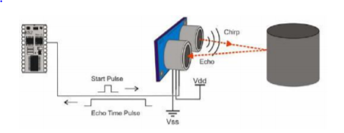
Fig.1: Schematic Diagram
The ultrasonic sensor consists of a multi vibrator, which fixed at its base. The multi vibrator is combination of a resonator and vibrator. The ultrasonic waves generated by the vibration are delivers to the resonator. Ultrasonic sensor actually consists of two parts: the emitter which produces a 40 kHz sound wave and detector which detects 40 kHz sound wave and sends electrical signal back to the microcontroller.
In our project, we are using HC-SR04 ultrasonic sensors which consist of 4 pins VCC, Trigger, Echo and GND.
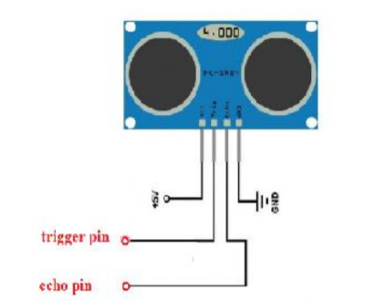
Fig.2: HC-SR04 Sensor Diagram

Algorithm-working principle:
The sonar system is used in HC-SR04 ultrasonic sensor to determine distance to an object like bats do. It offers excellent non-contact range detection from about 2 cm to 400 cm or 1’’ to 13 feet. Its operation is not affected by sunlight or black material.
The ultrasonic sensor emits the short and high frequency signal. If they detect any object, then they reflect back echo signal which taken as input to the sensor through Echo pin.
Firstly, we initialize Trigger and Echo pin as low and push the robot in forward direction. when obstacle is detected Echo pin will give input as high to microcontroller. pulseIn() function is used for calculating the time of distance from the obstacle. Every time the function waits for pin to go high and starts timing, then timing will be stopped when pin go to low. It returns the pulse length in microseconds or when complete pulse was not received within the timeout it returns 0.
The timing has been determined means it gives length of the pulse and will show errors in shorter pulses. Pulses from 10microseconds to 3 minutes in length are taken into consideration.
After determining the time, it converts into a distance. If the distance of object is moderate then speed of robot gets reduced and will take left turn, If obstacle is present in left side then it will take right turn.
If the distance of object is short then speed of robot gets reduced and will turn in backward direction and then can go in left or right direction.

Implementation:
The implementation of obstacle avoidance strategy for robot involves the writing and compilation of program using Arduino software. Arduino is a popular programmable board used to create projects. It consists of a simple hardware platform on which microcontroller is placed as well as a free code editor which has a “one click compiles or upload” feature. Hence it is designed for the peoples in such a way that they can use it without necessarily being an expert programmer. Arduino offers an open-source electronic prototyping platform that is easy to use and flexible for peoples who are beginners in robotics field with both the software and hardware perspective.

The general block diagram for the complete execution is as Follow:

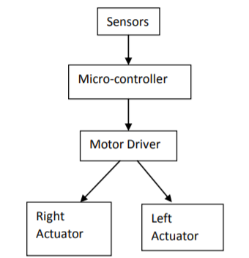
Fig.4: Block Diagram of obstacle avoidance robot

Sensors are connected with the Arduino board using breadboard. Microcontroller is able to sense the environment through receiving input from sensors. It is also able to control its surrounding through controlling motors and other actuators.
The Arduino programming language that is based on the processing are used to program the microcontroller found on the board. Due to its opensource environment, we can able to easily write and upload codes to the board. Arduino environment is written in Java hence it can be run on Linux, Mac OSX and Windows platforms.
The output of the comparator is given to the microcontroller, which then moves actuators in left or right direction by giving power through DC motor.

Testing:
First of all, we checked the circuit as per the circuit diagram. Then After switching on the button, robot moves around as it is directed in the program. Whenever the obstacle comes in the way of the robot, ultrasonic sensor detects the object and moves in the left direction until the object disappears.

Result:
The outcome of the thesis is a simple, PC-controlled robot controlled which moves around detecting the obstacles on its way and thus making its way through the free space avoiding all the obstacles it encounters.
After the completion of the robot, the robot can now emit IR ray through the IR emitter, and the IR receiver will detect receive the bounced IR ray that strikes the obstacles if there are any. If there are any obstacles and IR collide with them, then brain of the robot (micro controller) will calculate the distance. The robot is made activated after the switch on the activity board is turned on. If there seems to have any obstacle with in the distance set to it, it will move to the left direction of the obstacle detected. Overall, robot performed very well. However, there had to be many adjustments made to robot in order to achieve our destination before the tests started.

Future Scope of work:
In future, the sensing range can be increased by increasing the sensor quality with the help of ultrasonic sensor or the IR signal spread all over the provide area. Performance of this robot can be improved with the help of Bump sensors, for slow moving robots, Ultrasonic range sensors for large range up to 6m or LASER range finders. One of the prevailing fields is the use of camera in robot, Computer vision can be implemented for better performance.
Conclusion:

We build a robotic vehicle which moves in different directions like Forward, Backward and right when input is given to it.
The goal of our project is to create an autonomous robot which intelligently detects the obstacle in his path and navigate according to the actions that we set for it.

References:
[1] Obstacle avoidance robotic vehicle using ultrasonic sensors for obstacle detection:http://www.elprocus.com/obstacle-avoidancerobotic-vehicle/
[2] How to make an obstacle avoiding robot: http://www.instructables.com/id/How-To-Make-anObstacle-Avoiding-Arduino-Robot/
[3] IEEE paper for Obstacle avoidance robot using ultrasonic sensors: https://ieeexplore.ieee.org/document/2085
[4] Obstacle avoiding robot without microcontroller: http://www.roboticsbible.com/project-obstacleavoiding-robot.html
[5] How to build an obstacle avoiding robot: https://www.youtube.com/watch?v=JZ5JjvfY1Eg
[6] Complete guide for Ultrasonic sensor HC-SR04 Tutorials: http://randomnerdtutorials.com/complete-guide-forultrasonic-ssensor-hc-sr04/

Appendix:
Code

#include <AFMotor.h> //import your motor shield library
#define trigPin 12 // define the pins of your sensor
#define echoPin 13
AF_DCMotor motor1(1,MOTOR12_64KHZ); // set up motors.
AF_DCMotor motor2(2, MOTOR12_8KHZ);

void setup() {
Serial.begin(9600); // begin serial communitication
Serial.println("Motor test!");
pinMode(trigPin, OUTPUT);// set the trig pin to output (Send sound waves)
pinMode(echoPin, INPUT);// set the echo pin to input (recieve sound waves)
motor1.setSpeed(200); //set the speed of the motors, between 0-255
motor2.setSpeed (200);
}

void loop() {

long duration, distance; // start the scan
digitalWrite(trigPin, LOW);
delayMicroseconds(2); // delays are required for a succesful sensor operation.
digitalWrite(trigPin, HIGH);

delayMicroseconds(10); //this delay is required as well!
digitalWrite(trigPin, LOW);
duration = pulseIn(echoPin, HIGH);
distance = (duration/2) / 29.1;// convert the distance to centimeters.
if (distance < 25)/*if there's an obstacle 25 centimers, ahead, do the following: */ {
Serial.println ("Close Obstacle detected!" );
Serial.println ("Obstacle Details:");
Serial.print ("Distance From Robot is " );
Serial.print ( distance);
Serial.print ( " CM!");// print out the distance in centimeters.

Serial.println (" The obstacle is declared a threat due to close distance. ");
Serial.println (" Turning !");
motor1.run(FORWARD); // Turn as long as there's an obstacle ahead.
motor2.run (BACKWARD);

}
else {
Serial.println ("No obstacle detected. going forward");
delay (15);
motor1.run(FORWARD); //if there's no obstacle ahead, Go Forward!
motor2.run(FORWARD);
}

}

M.V.S.R ENGINEERING COLLEGE
(Affiliated to Osmania University, Hyderabad. Recognized by AICTE)
Nadergul, Saroornagar Mandal, Hyderabad-501510

DEPARTMENT OF INFORMATION TECHNOLOGY

Certificate

Certified that this a bonafide Mini Project work carried out by
Mr./Ms. __________________________________ Bearing H.T. No.______________________ in the course Mini Project PC ____IT prescribed for B.E( /4 ) Sem: ____ by Osmania University, in the department during the academic year 20 - 20

Faculty in-Charge Guide Signature

Head of the Department

